Lab Exercise 10- Creating and Managing a ReplicaSet in Kubernetes

Objective:

A ReplicaSet in Kubernetes ensures a specified number of Pod replicas are running at any given time. This exercise will guide you through creating a ReplicaSet to maintain the desired state of your application.

- Understand the syntax and structure of a Kubernetes ReplicaSet definition file (YAML).
- Learn how to create and manage a ReplicaSet to ensure application availability.
- Understand how a ReplicaSet helps in scaling applications and maintaining desired states.

Prerequisites

- Kubernetes Cluster: Have a running Kubernetes cluster (locally using Minikube or kind, or a cloud-based service).
- kubectl: Install and configure kubectl to interact with your Kubernetes cluster.
- Basic Knowledge of YAML: Familiarity with YAML format will be helpful for understanding Kubernetes resource definitions.

Step-by-Step Guide

Step 1: Understanding ReplicaSet

A ReplicaSet ensures a specified number of Pod replicas are running at any given time. If a Pod crashes or is deleted, the ReplicaSet creates a new one to meet the defined number of replicas. This helps maintain application availability and ensures that your application can handle increased load by distributing traffic among multiple Pods.

Step 2: Create a ReplicaSet

We'll define a ReplicaSet to maintain three replicas of a simple Nginx web server Pod.
Create a YAML file named nginx-replicaset.yaml with the following content:
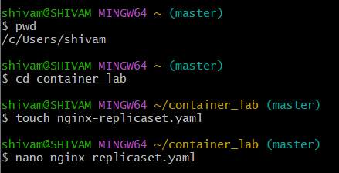

apiVersion: apps/v1
kind: ReplicaSet
metadata:
name: nginx-replicaset
spec:
replicas: 3
selector:
matchLabels:
app: my-app
template:
metadata:
labels:
app: my-app
spec:
containers:
- name: nginx
image: nginx:latest
ports:
- containerPort: 80

Explanation:

- apiVersion: Defines the API version (apps/v1) used for the ReplicaSet resource.
- kind: Specifies that this resource is a ReplicaSet.
- metadata: Contains metadata about the ReplicaSet, including name.
  - name: The unique name for the ReplicaSet.
- spec: Provides the specification for the ReplicaSet.
  - replicas: Defines the desired number of Pod replicas.
  - selector: Criteria for selecting Pods managed by this ReplicaSet.
    - matchLabels: Labels that Pods must have to be managed by this ReplicaSet.
  - template: Defines the Pod template used for creating new Pods.
    - metadata: Contains metadata for the Pods, including labels.
      - labels: Labels applied to Pods created by this ReplicaSet.
  - spec: Specification for the Pods.
    - containers: Lists the containers that will run in the Pod.
      - name: The unique name of the container within the Pod.
      - image: The Docker image used for the container.
      - ports: Ports exposed by the container.

Step 3: Apply the YAML to Create the ReplicaSet

Use the kubectl apply command to create the ReplicaSet based on the YAML file.

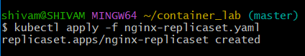
Verify the ReplicaSet is running and maintaining the desired number of replicas:

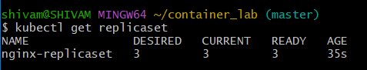
This command lists all ReplicaSets in the current namespace.

To check the Pods created by the ReplicaSet:

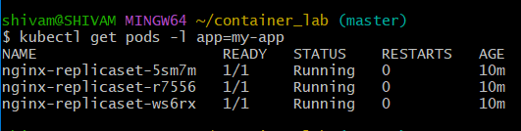
This command lists all Pods with the label app=nginx.

Step 4: Managing the ReplicaSet

1. Scaling the ReplicaSet

You can scale the number of replicas managed by the ReplicaSet using the kubectl scale command.

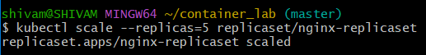
This command scales the ReplicaSet to maintain 5 replicas. Verify the scaling operation:

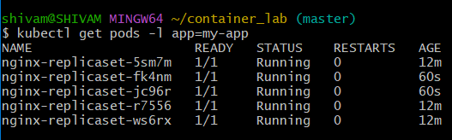
You should see that the number of Pods has increased to 5.

2. Updating the ReplicaSet

If you need to update the Pod template (e.g., to use a different Docker image version), modify the YAML file and apply it again. For instance, change the image to a specific nanoversion of Nginx:

spec:
template:
spec:
containers:
- name: nginx
image: nginx:1.19.3 # Change to a specific version

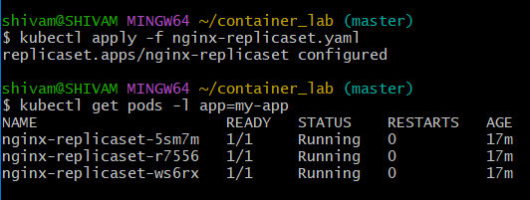
Note: Updating a ReplicaSet doesn't automatically replace existing Pods with new ones. In practice, you often create a new ReplicaSet or Deployment for updates.

3. Deleting the ReplicaSet

To clean up the ReplicaSet and its Pods, use the kubectl delete command:

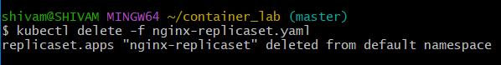
This command deletes the ReplicaSet and all the Pods managed by it.

